

**SYSTEM ANALYSIS AND DESIGN**

Charity Second-hand Online Store

**Revised records**

|  |  |  |  |
| --- | --- | --- | --- |
| **Update Date** | **Version** | **Description** | **Name** |
| 27th March 2020 | V1.0 | Initial version | Guozhi Yin |
| 11th April 2020 | V1.1 | Add diagrams | Cong Shang |
| 20th April 2020 | V1.2 | Update details | Guozhi Yin |
| 20th April 2020 | V1.3 | Update the business process diagram and class diagram | Cong Shang |

Table of Contents

1 Summary 4

1.1 System Objectives 4

1.2 Background 4

1.3 Resource 4

1.4 Costs and Benefits 5

1.5 Milestones 6

2 Current environment description 7

2.1 Current system overview 7

2.2 Current system hardware, software and network 7

3 Requirement Specification 9

3.1 User Requirements Document 9

3.1.1 Proposed System Overview 9

3.1.2 System User Profile 9

3.1.3 Business Process 9

3.1.4 Business Model 10

3.1.5 Functional Requirements 30

3.1.6 Non-functional Requirements 32

4 System specification 34

4.1 Architecture Diagram 34

4.2 Class Diagram 34

4.2.1 Entity Bean 35

4.2.2 Servlet 35

4.2.3 DAO 36

4.3 Data Model 37

4.3.1 Entity Relationship Diagram 37

4.3.2 Data Dictionary 37

4.4 Use Case Diagram 40

4.4.1 Commodity and auction. 40

4.4.2 User management. 41

5 Prototype 41

5.1 Main Page 41

5.2 Contact Us 42

5.3 About Us 43

5.4 Registration 44

5.5 Login 44

5.6 Logout 45

5.7 Password Recover 45

5.8 Personal Information 46

5.9 Auction 47

5.10 Make Appointments 48

5.11 Goods Management 48

5.12 Shopping Cart 50

5.13 User Management 51

5.14 Order Management 51

# Summary

## System Objectives

We plan to set up an online auction store for the second-hand store. Residents can browse high quality second-hand goods online. If the auction is successful, customers can make an appointment to pick up the goods and finish the payment in the store, which will greatly increase the number of participants, improve the transaction efficiency and increase the turnover.

## Background

Our client is Zoe Liu who works as an accountant at the Salvation Army church in Lower Hutt. The church has a nationwide second-hand store called Salvation Army Family Store, which collects donated items from residents (clothing, toys, kitchen stuff, etc.). It provides physical stores for residents who like second-hand goods, and the income will be used to fund the operation of the church and help people in difficult areas.

However, the information construction of the second-hand store attached to the church is relatively backward. The store does not have an online store, so it cannot give consumers a better shopping experience.

Although we have a client who is employed by the Salvation Army, this project could be rolled out and utilized by any other charity and not exclusively for the Salvation Army. Therefore this project will be created with this in mind.

## Resource

|  |  |  |
| --- | --- | --- |
| Name | **Availability** | **Role** |
| Zoe Liu | 10 Hours (Project Meeting, Change Request) | Client |
| Ian Hunter | 12 Hours (Project Meeting, Project Monitoring) | Project Advisor |
| Guozhi Yin | 450 Hours | Project Manager  Product Designer,  Database Administrator,  Testing  Documentation |
| Cong Shang | 450 Hours | Software Developer  (Front-end, Back-end),  Testing,  Documentation |

## Costs and Benefits

Costs

Since the project team will use open source and free versions of the software development tools, there will be no financial cost to the customer. There is a time cost to the project team, with each member expected to spend 450 hours on project planning, design, development, testing, and documentation.

Benefits

The system is expected to bring the following benefits to our client:

* Promote the information construction of second-hand shops.
* Improve the user experience.
* Increase revenue.

## Milestones

|  |  |  |
| --- | --- | --- |
| **Milestones** | **Activity** | **Estimated Date** |
| Phase1  Proposal | Bid | 20th March |
| Requirement Analysis |
| Proposal |
| Phase2  System analysis and design | System Diagrams | 19th April |
| Prototype |
| Database Design |
| Data Dictionary |
| Phase3  Development | Set up Development Environment | 15th May |
| Front-end Development |
| Back-end Development |
| Phase4  Testing | Unit Testing | 26th May |
| Integration Testing |
| System Testing |
| User Acceptance Testing |
| Testing Report |
| Phase5  Client handover | User Manual | 29th May |
| System Go-live |
| User Training |
| Client Handover |

# Current environment description

## Current system overview

The project team will develop a second-hand online auction site for the client, which contains the following main functional modules:

* Registration
* Login authentication
* Search for items
* Auction
* Make appointments to pick up

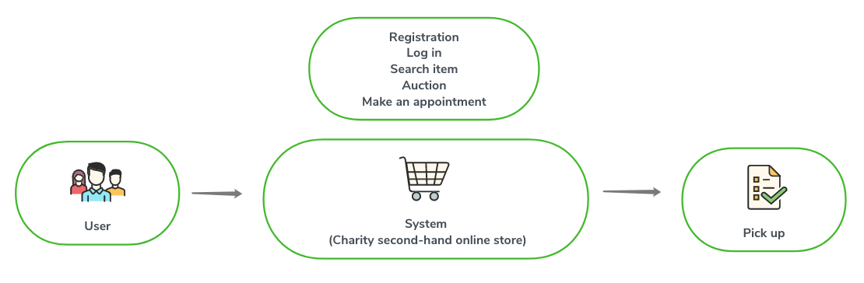

## Current system hardware, software and network

To complete the project, the project team needs to prepare software and hardware resources. To reduce project costs, the project team will try to use free software as much as possible. For the hardware resources, the project team will use our laptops.

The following table shows the resources required for project development and testing:

|  |  |  |  |  |  |  |
| --- | --- | --- | --- | --- | --- | --- |
|  | **Item** | **Version** | **quantity** | **Finish time** | **Remark** | |
| **Software** | | | | | | |
| Database | MySQL | V8.0 | 4 | 3/16/2020 | Michael | |
| Navicat for MySQL | V10.0.11 | 3 | 3/16/2020 | Michael | |
| Application server： | Tomcat | V8.5 | 4 | 3/16/2020 | Cong | |
| IDE | Eclipse | V2019-3(4.11) | 3 | 3/16/2020 | Cong | |
| **Hardware** | | | | | | |
| Laptop | CUP*2  Memory：8GB  DDH：200GB | | 3 | Completed | | Using team member’s laptop |
| Testing server | CUP*2  Memory：8GB  DDH：200GB | | 1 | 4/11/2020 | | Installed MySQL and Tomcat.  Cong is responsible for preparing |

# Requirement Specification

## User Requirements Document

### Proposed System Overview

The proposed Charity second-hand online store would allow users to log in, browse, find items they like and bid on targeted items using a computer or mobile phone. If the bid is successful, the system allows users to apply for a pickup time and go to the store to pick up the goods, pay for the goods and complete the transaction.

### System User Profile

The following provides a table of external and internal users of the website. Each user will have a role in the system.

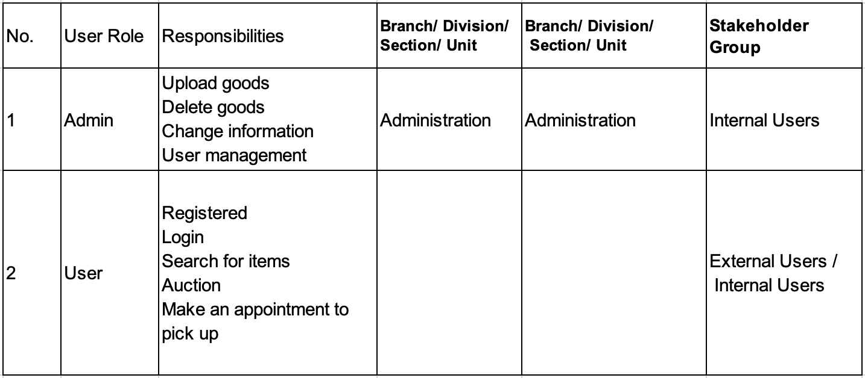

### Business Process

#### List of Business Processes

|  |  |
| --- | --- |
| Process ID | Business Process Title |
| BP-001 | Registration |
| BP-002 | Login |
| BP-003 | Password recover |
| BP-004 | Personal information |
| BP-005 | Auction |
| BP-006 | Make appointments |
| BP-007 | Goods management |
| BP-008 | Shopping cart |
| BP-009 | User management |
| BP-010 | Order management |

### Business Model

#### BP-001 Registration

|  |  |  |
| --- | --- | --- |
| User case ID: | BP-001 | |
| User case name: | Registration | |
| Triggering event: | User/Administrator wants to create a new account | |
| Description: | The requirement of the registration is to create a new account for user. | |
| Actors: | User/Administrator | |
| Stakeholders: |  | |
| Preconditions: | User/Administrator does not have an account. | |
| Postconditions: |  | |
| Flow of activities: | Actor | System |
| User/Administrator needs to fill in the user registration form | To create a new account for user/administrator |
|
| Exception conditions: |  | |

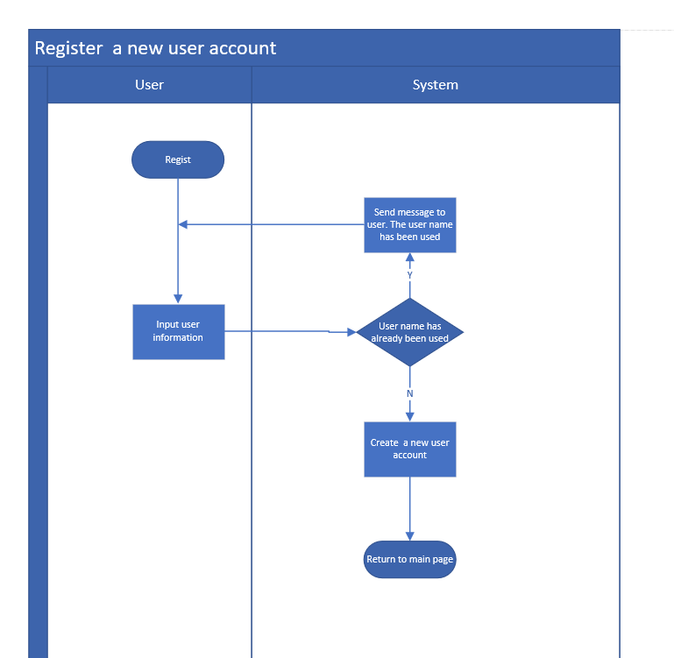

#### BP-002 Login

|  |  |  |
| --- | --- | --- |
| User case ID: | BP-002 | |
| User case name: | Login | |
| Triggering event: | User/Administrator inputs username and password on the page of login. | |
| Description: | The requirement of the login is to login the website by using an existing account. | |
| Actors: | User/Administrator | |
| Stakeholders: |  | |
| Preconditions: | User/Administrator has an existing account. | |
| Postconditions: |  | |
| Flow of activities: | Actor | System |
| User/Administrator inputs username and password | To verify if the username or password is right. If they are right, permit users to login. If they are wrong, giving an error message. |
|
| Exception conditions: |  | |

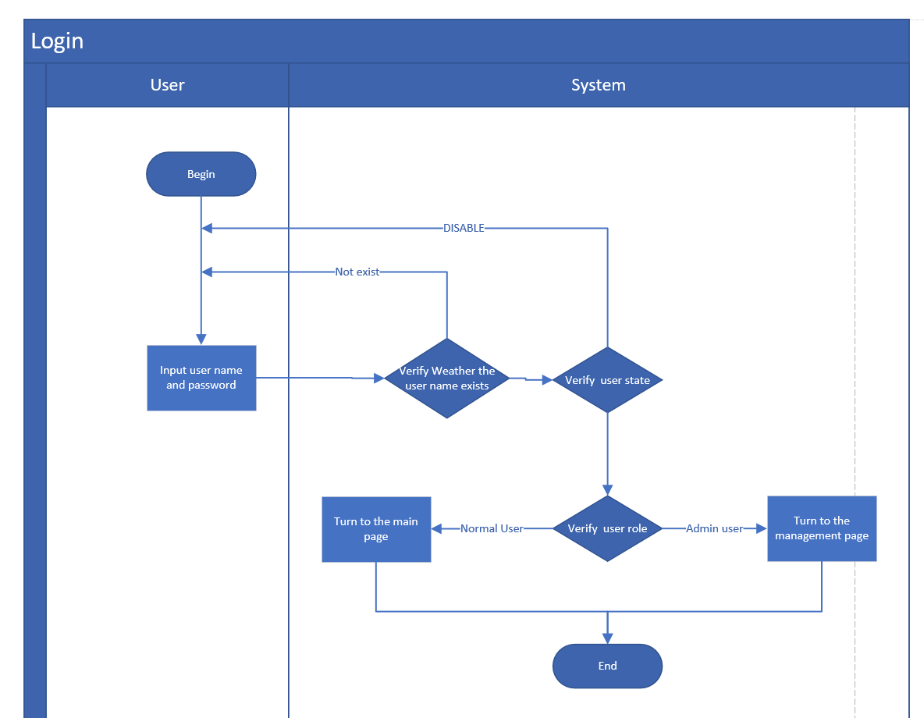

#### BP-003 Password recover

|  |  |  |
| --- | --- | --- |
| User case ID: | BP-003 | |
| User case name: | Password recover | |
| Triggering event: | User/Administrator wants to find the forgotten password. | |
| Description: | The requirement is to change a new password when a user forgot his/her password. It will verify user’s mobile number and email information. | |
| Actors: | User/Administrator | |
| Stakeholders: |  | |
| Preconditions: | User/Administrator has an existing account. | |
| Postconditions: |  | |
| Flow of activities: | Actor | System |
| User/Administrator needs to input email and mobile information. | To verify if email and mobile are right. If the verification is failed, the process of password recover will be failed. |
|
| Exception conditions: |  | |

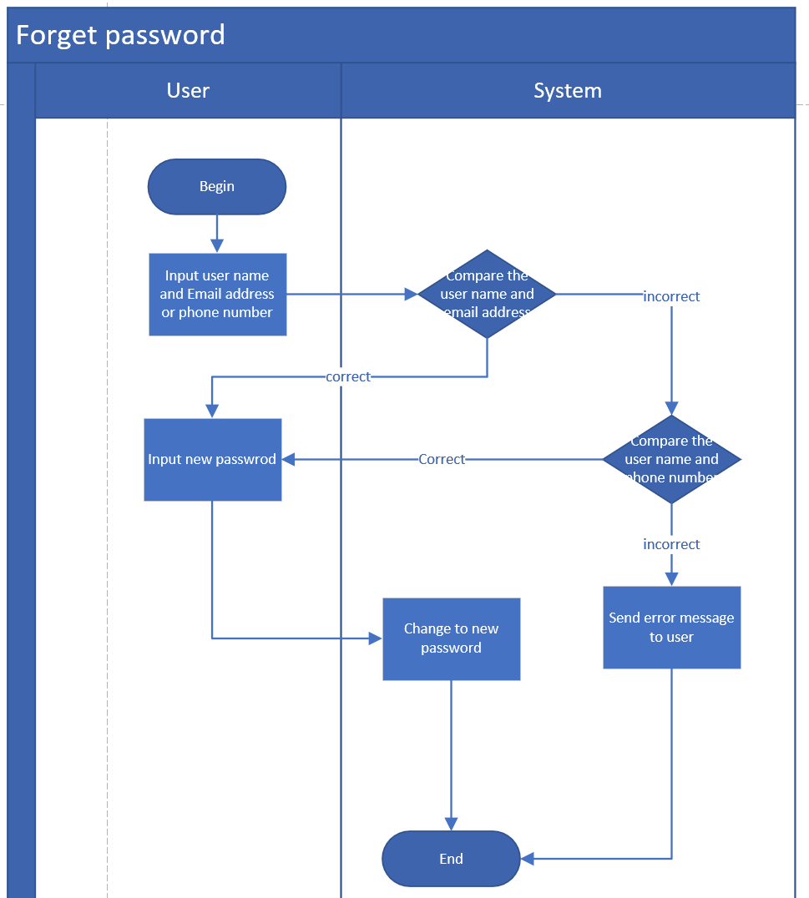

#### BP-004 Personal information

|  |  |  |
| --- | --- | --- |
| User case ID: | BP-004 | |
| User case name: | Personal information | |
| Triggering event: | User/Administrator wants to view or modify his/her personal information. | |
| Description: | The requirement of the personal information can display the details of personal information and support user to modify them. | |
| Actors: | User/Administrator | |
| Stakeholders: |  | |
| Preconditions: | User/Administrator has an existing account. | |
| Postconditions: |  | |
| Flow of activities: | Actor | System |
| User/Administrator can modify personal information | To update personal information. |
|
| Exception conditions: |  | |

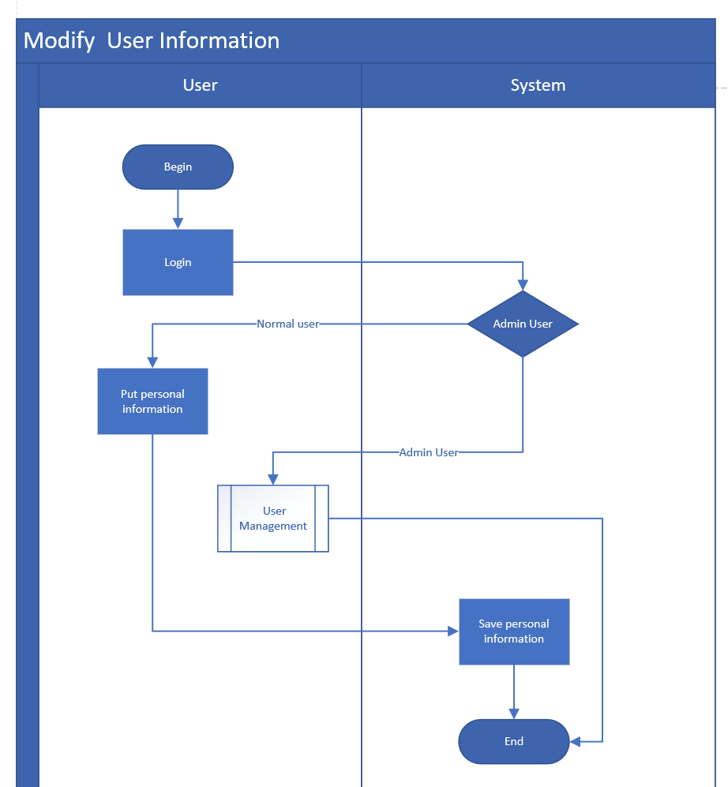

#### BP-005 Auction

|  |  |  |
| --- | --- | --- |
| User case ID: | BP-005 | |
| User case name: | Auction | |
| Triggering event: | User/Administrator wants to bid a product. | |
| Description: | The requirement of auction supports users to bid goods and view the bid history. It is failed when the bid price is less than current price. If the user does not login, the auction cannot be operated. | |
| Actors: | User/Administrator | |
| Stakeholders: |  | |
| Preconditions: | User/Administrator has an existing account. | |
| Postconditions: |  | |
| Flow of activities: | Actor | System |
| User/Administrator bids a product. | To verify if the price is less than the current one. To display the price in the list of bid history. |
|
| Exception conditions: |  | |

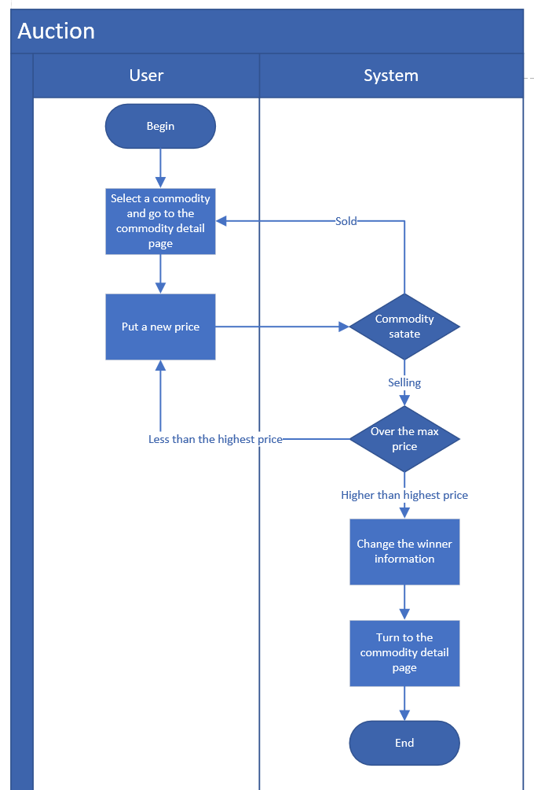

#### BP-006 Make appointments

|  |  |  |
| --- | --- | --- |
| User case ID: | BP-006 | |
| User case name: | Make appointments | |
| Triggering event: | User/Administrator wants to pick up the product that he/she won. | |
| Description: | The requirement is to support user to make an appointment and pick up the goods in the store. The transaction will be closed. | |
| Actors: | User/Administrator | |
| Stakeholders: |  | |
| Preconditions: | User/Administrator won an auction. | |
| Postconditions: |  | |
| Flow of activities: | Actor | System |
| User/Administrator can input the time and information for the appointment. | To record the appointment information, and support administrator review it. |
|
| Exception conditions: |  | |

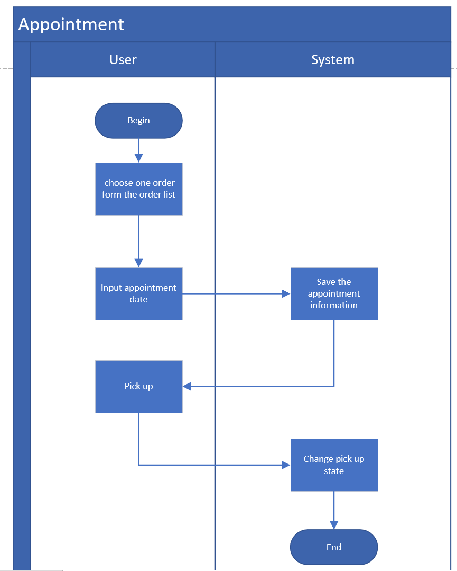

#### BP-07 Goods management

|  |  |  |
| --- | --- | --- |
| User case ID: | BP-07 | |
| User case name: | Goods management | |
| Triggering event: | Administrator wants to manage goods. | |
| Description: | The requirement is to support administrator to manage goods, including uploading, modification and deleting | |
| Actors: | Administrator | |
| Stakeholders: |  | |
| Preconditions: | Administrator enters the page of goods management. | |
| Postconditions: |  | |
| Flow of activities: | Actor | System |
| Administrator can upload, modify or delete products. | To update the operation actions. |
|
| Exception conditions: |  | |

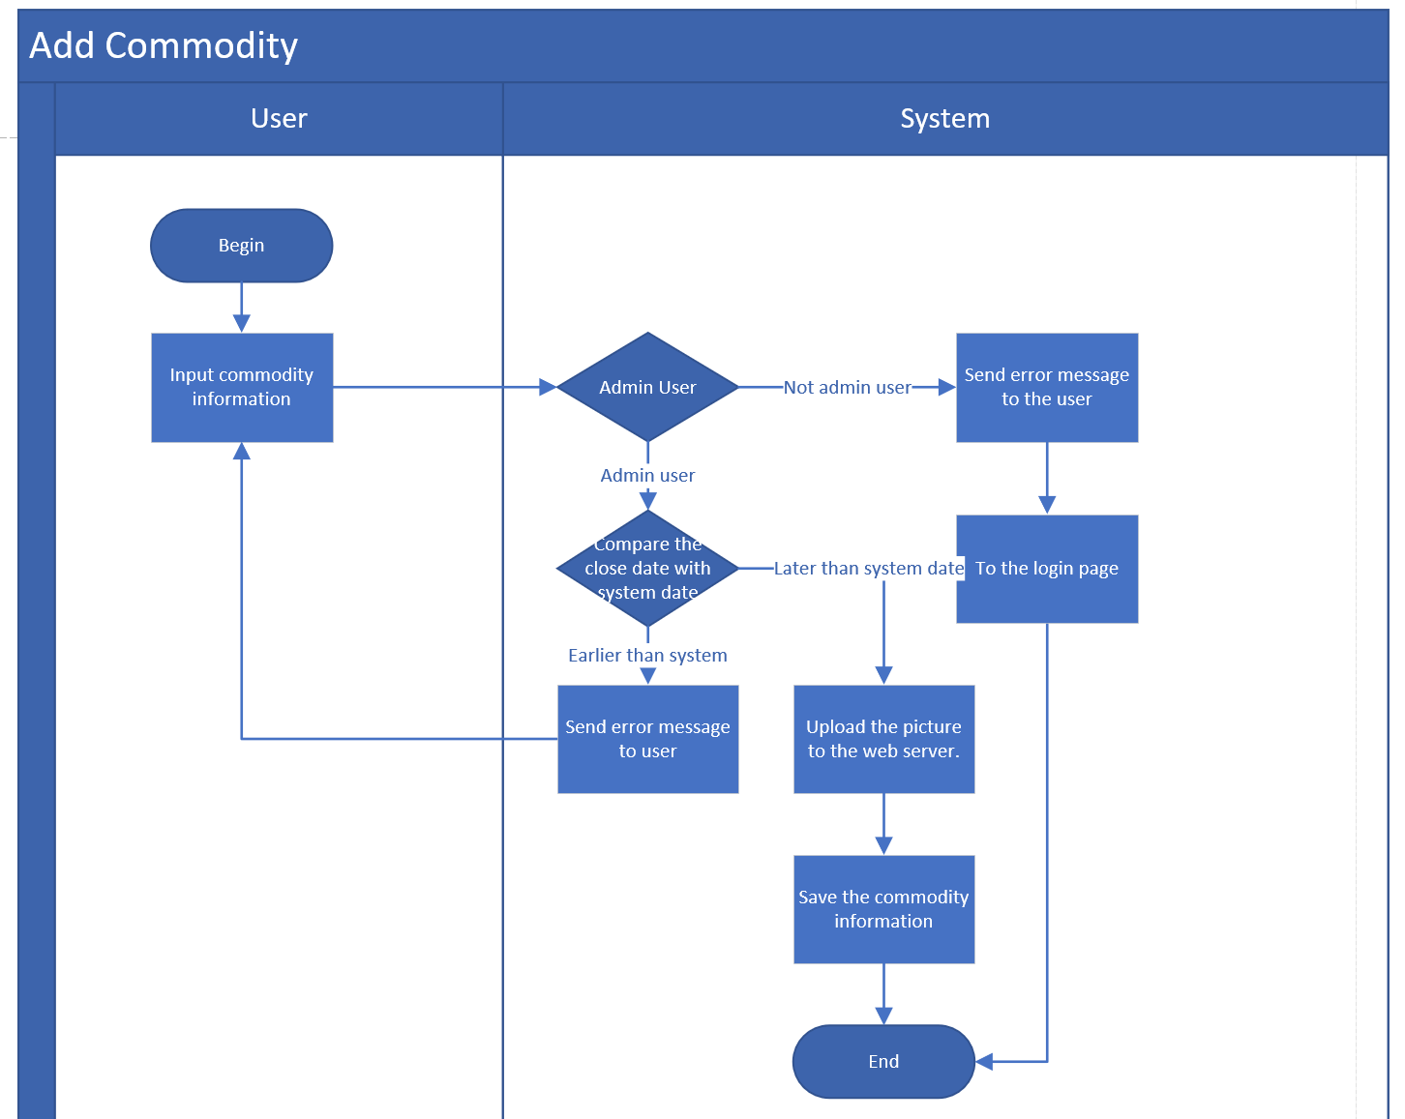

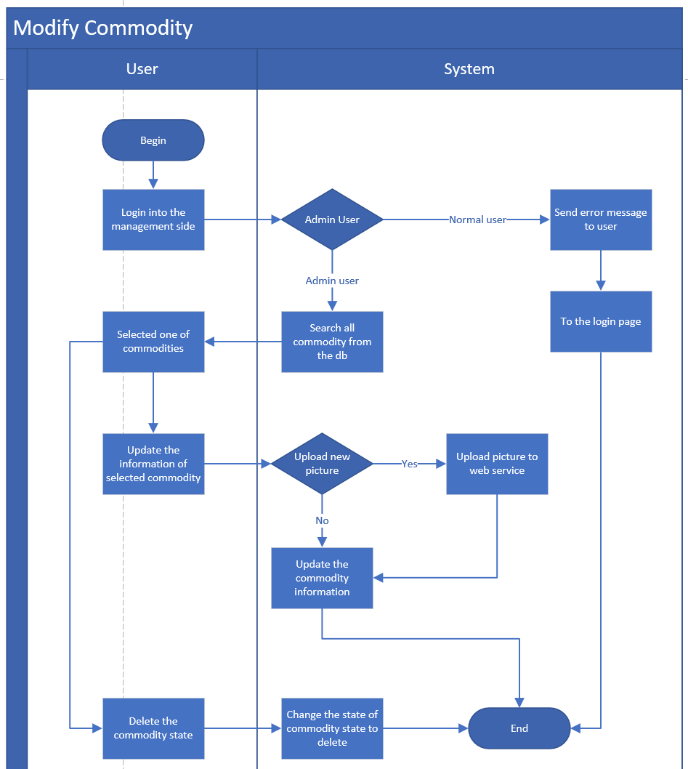

#### BP-008 Shopping cart

|  |  |  |
| --- | --- | --- |
| User case ID: | BP-008 | |
| User case name: | Shopping cart | |
| Triggering event: | User/Administrator wants to save some products that he/she likes. | |
| Description: | The requirement is to support users to add favourite goods into the cart. | |
| Actors: | User/Administrator | |
| Stakeholders: |  | |
| Preconditions: | User/Administrator has an existing account | |
| Postconditions: |  | |
| Flow of activities: | Actor | System |
| User/Administrator can add some products info the shopping cart | To add these product into user’s shopping cart. |
|
| Exception conditions: |  | |

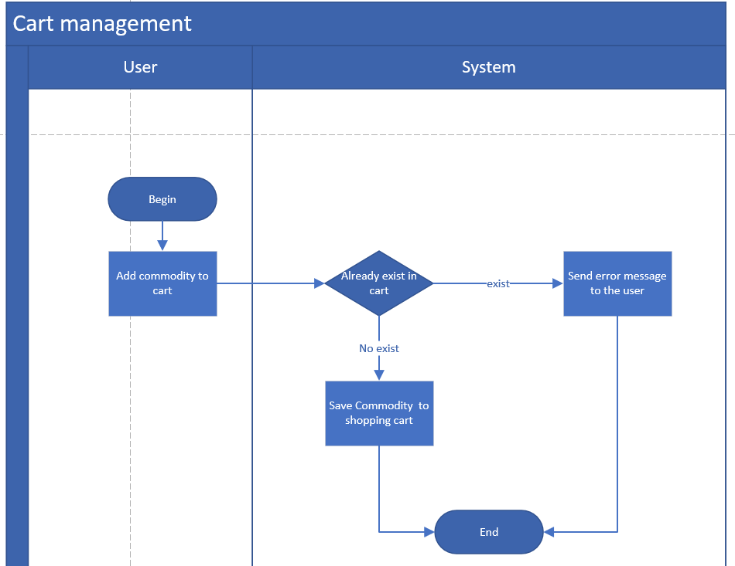

#### BP-009 User management

|  |  |  |
| --- | --- | --- |
| User case ID: | BP-009 | |
| User case name: | User management | |
| Triggering event: | Administrator wants to manage user’s status. | |
| Description: | The requirement is to support administrator to manage user, including changing user’s status, changing administrator’s status and viewing user list. | |
| Actors: | Administrator | |
| Stakeholders: |  | |
| Preconditions: | Administrator enters the page of goods management. | |
| Postconditions: |  | |
| Flow of activities: | Actor | System |
| Administrator can enable or disable user’s status. Administrator can also change a normal user to administrator. | To adjust user’s status. |
|
| Exception conditions: |  | |

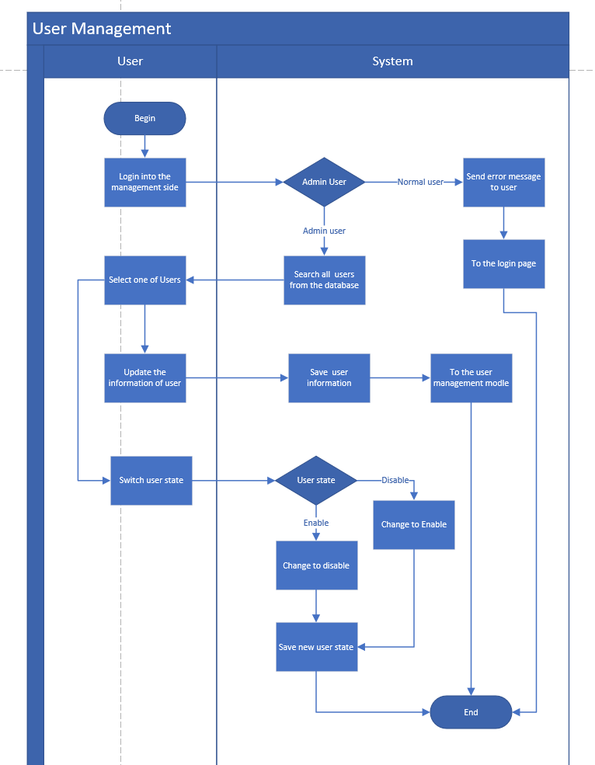

#### BP-010 Order management

|  |  |  |
| --- | --- | --- |
| User case ID: | BP-010 | |
| User case name: | Order management | |
| Triggering event: | Administrator wants to review or order order’s status. | |
| Description: | The requirement is to support administrator to manage order, including setting order’s status and viewing order list. | |
| Actors: | Administrator | |
| Stakeholders: |  | |
| Preconditions: | Administrator enters the page of order management. | |
| Postconditions: |  | |
| Flow of activities: | Actor | System |
| Administrator can adjust order’s status, such as not make an appointment, success, made an appointment. Administrator can also adjust order’s status. | To adjust order’s status. |
|
| Exception conditions: |  | |

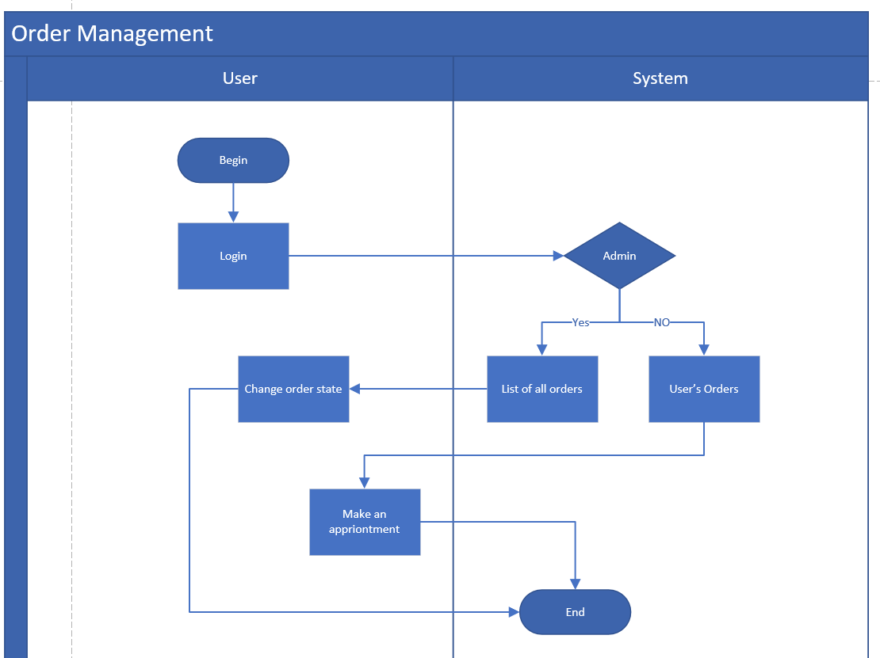

### Functional Requirements

#### Main Page

The function of the main page includes goods information, goods categories, search box and other details.

#### Contact Us

The function is to introduce the website. It should include map and text.

#### 

#### About Us

#### The function is to introduce the website. It should include picture and text.

#### Registration

The function of the registration is to create a new account for user.

#### Login

The function of the login is to login the website by using an existing account.

#### Logout

The function of the logout is to logout the website by using an existing account.

#### Password Recover

#### The function is to change a new password when a user forgot his/her password. It will verify user’s mobile number and email information.

#### 

#### Personal Information

The function of the personal information can display the details of personal information and support user to modify them.

#### Auction

The function of the personal information can display the details of personal information and support user to modify them.

#### Make Appointments

The function is to support user to make an appointment and pick up the goods in the store. The transaction will be closed.

#### Goods Management

The function is to support administrator to manage goods, including uploading, modification and deleting.

#### Shopping Cart

The function is to support users to add favourite goods into the cart.

#### User Management

The function is to support administrator to manage user, including changing user’s status, changing administrator’s status and viewing user list.

#### Order Management

The function is to support administrator to manage order, including setting order’s status and viewing order list.

### Non-functional Requirements

#### Layout and Colour

The online store’s layout and colour should be consistent with the layout and colour of the main church website.

#### Performance

The website can support multiple users to visit at the same time, to ensure the reliability of high concurrency.

Support mainstream browsers of PC terminal and mobile terminal (such as Chrome, Safari, IE).

#### Availability

The site will ensure features are available, bug-free, and the system responds quickly.

#### Reliability

The website will ensure that the technical framework is reasonable. Interface and page response time is reliable, and the user’s operation is not abnormal.

#### Maintainability

When there is a problem in the system, it can be quickly located to solve the problem. The team should ensure the rationality of the code design.

#### Security

Ensure the security of the database, the security of the user’s data, and the security of login permission control.

# System specification

## Architecture Diagram

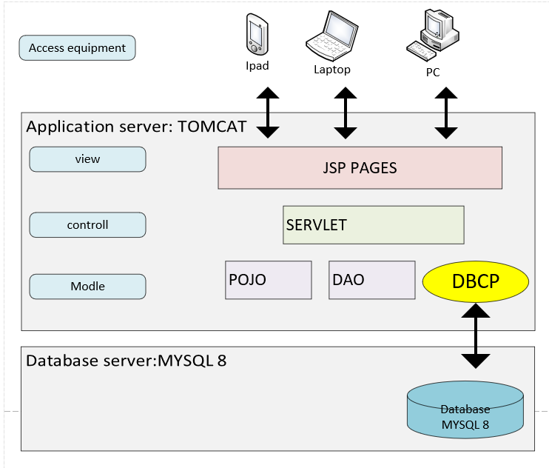

## Class Diagram

### Entity Bean

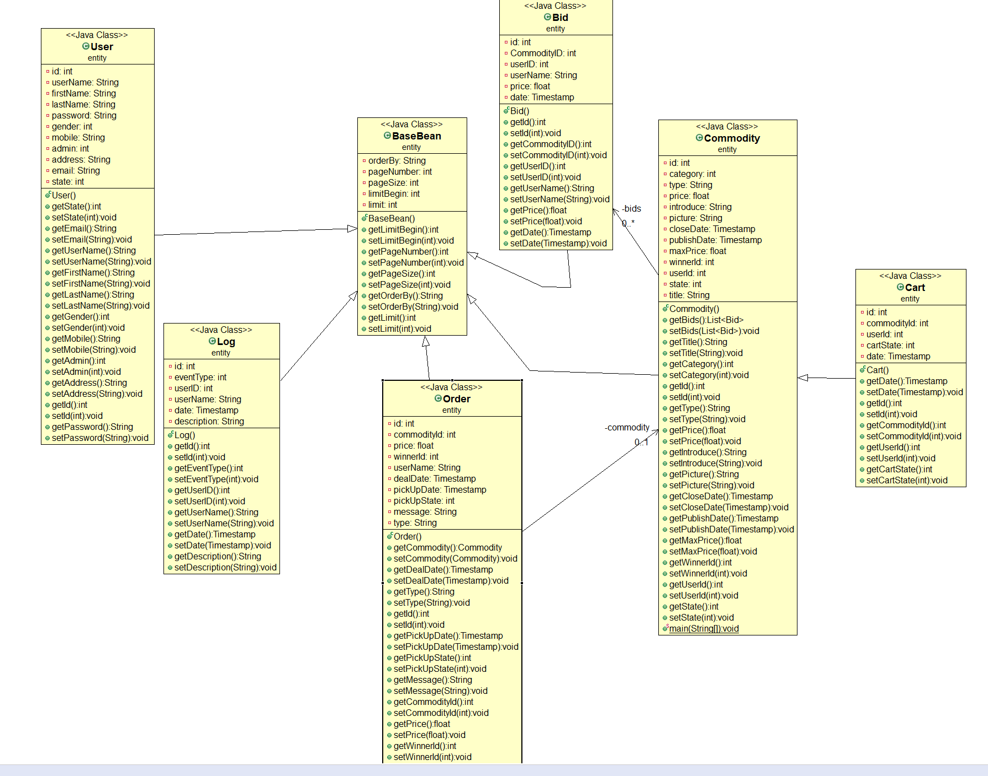

### Servlet

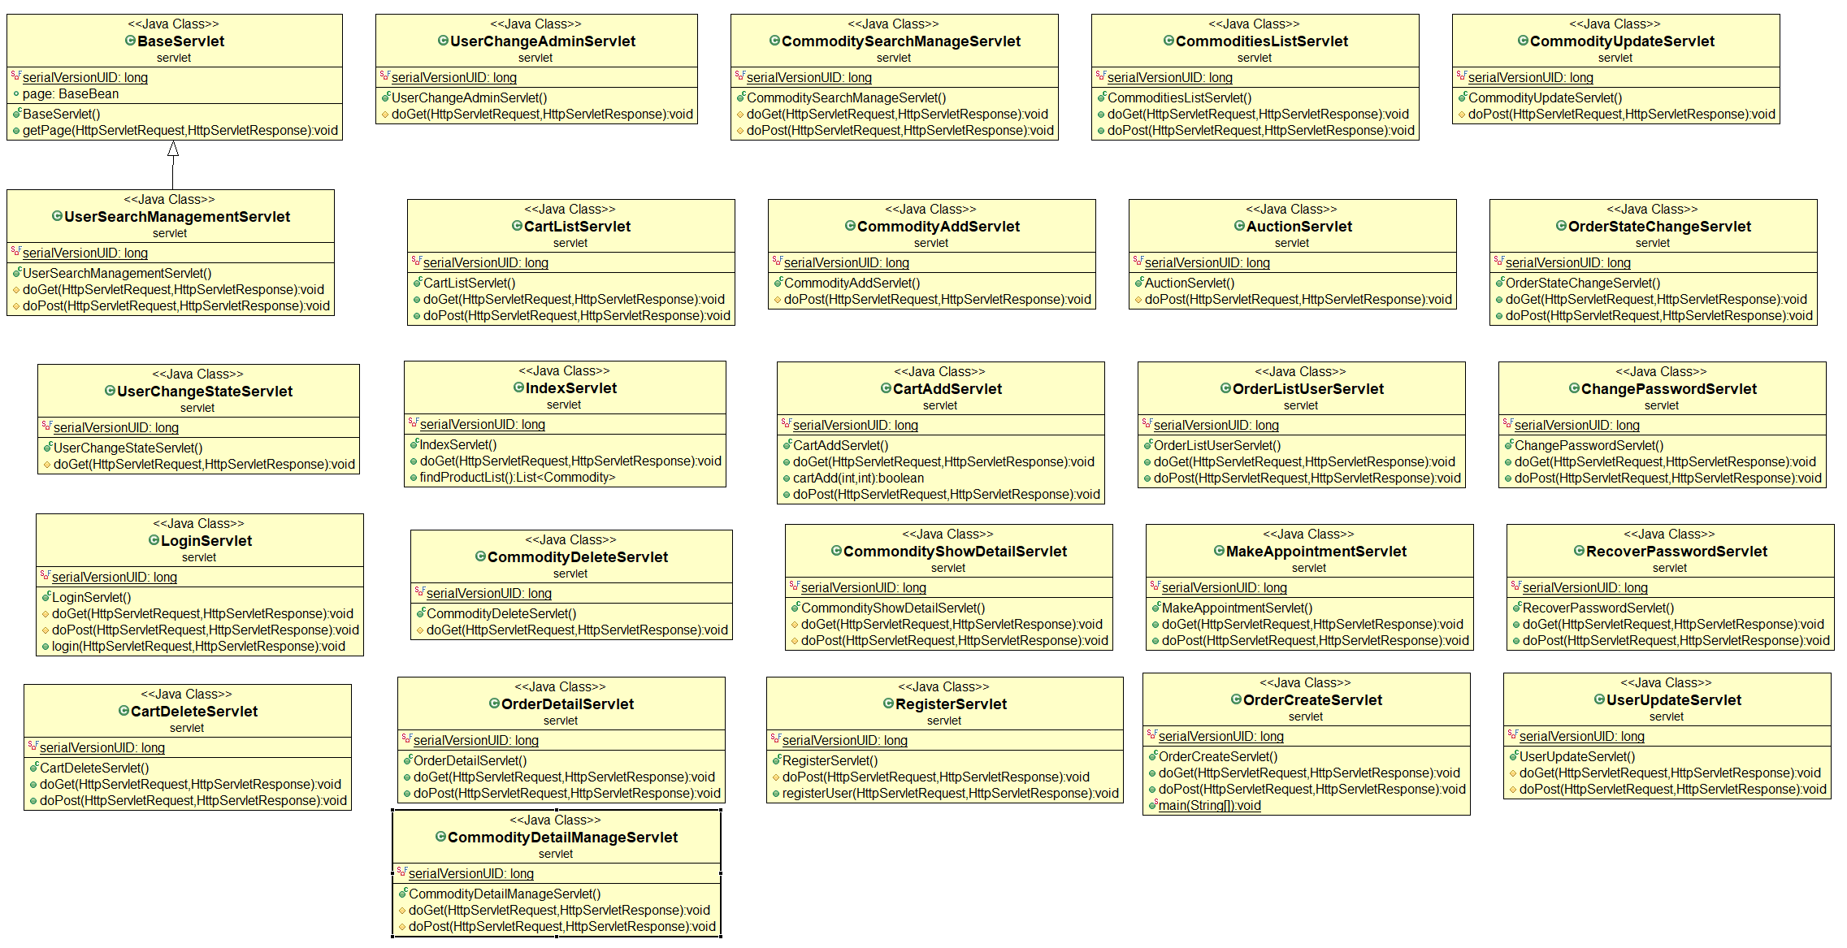

### DAO

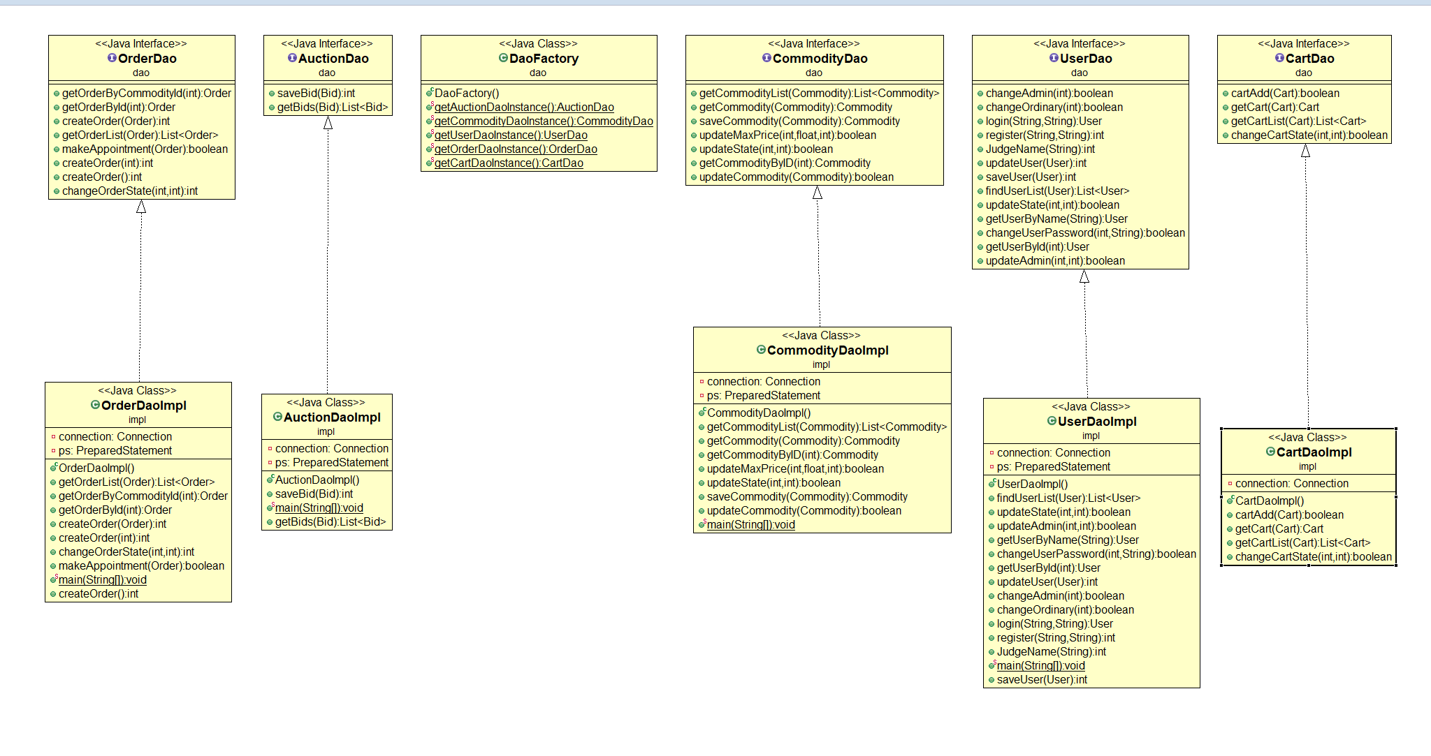

## Data Model

### Entity Relationship Diagram

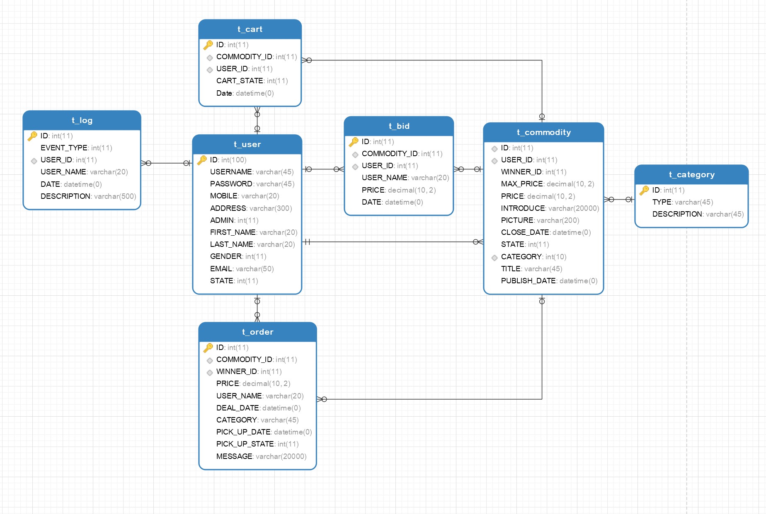

### Data Dictionary

|  |  |  |  |  |  |  |
| --- | --- | --- | --- | --- | --- | --- |
| TABLE_NAME | T_COMMODITY |  |  |  |  |  |
| COLUMN_NAME | DATATYPE | PK | FK | NOT NULL | DEFAULT | REMARKS |
| ID | INT(11) | Y |  | Y |  |  |
| USER_ID | INT(11) | N |  |  |  | PBULISHER USER ID |
| WINNER_ID | INT(11) | N | T_USER.ID |  |  |  |
| MAX_PRICE | DECIMAL(10,2) | N |  |  |  |  |
| PRICE | DECIMAL(10,2) | N |  | Y |  |  |
| INTRODUCE | VARCHAR(200) | N |  |  |  |  |
| PICTURE | VARCHAR(200) | N |  |  |  |  |
| CLOSE_DATE | DATETIME | N |  | Y |  |  |
| STATE | INT(11) | N |  | Y |  | 1:SOLD，  2:SELLING ， 3:DELETED |
| CATEGORY | INT(11) | N |  |  |  |  |
| TITLE | VARCHAR(45) | N |  | Y |  |  |
| PUBLISH_DATE | DATETIME | N |  | Y |  |  |

|  |  |  |  |  |  |  |
| --- | --- | --- | --- | --- | --- | --- |
| TABLE_NAME | T_USER |  |  |  |  |  |
| COLUMN_NAME | DATATYPE | PK | FK | NOT NULL | DEFAULT | REMARKS |
| ID | INT (11) | Y |  | Y |  |  |
| USERNAME | VARCHAR (20) | N |  | Y |  |  |
| FIRST_NAME | VARCHAR (20) | N |  |  |  |  |
| LAST_NAME | VARCHAR (20) | N |  |  |  |  |
| PASSWORD | INT (11) | N |  | Y |  |  |
| GENDER | INT(11) | N |  |  |  |  |
| MOBILE | VARCHAR(20) | N |  |  |  |  |
| ADDRESS | VARCHAR(300) | N |  |  |  | 1: ADMIN ,  2: NORMAL USER |
| ADMIN | INT(11) | N |  |  | 1 |  |
| EMAIL | VARCHAR (50) | N |  |  |  |  |
| STATE | INT(11) | N |  | Y |  | 1: ENABLE, 2: DISABLE |

|  |  |  |  |  |  |
| --- | --- | --- | --- | --- | --- |
| TABLE_NAME | T_BID |  |  |  |  |
| COLUMN_NAME | DATATYPE | PK | FK | NOT NULL | DEFAULT |
| ID | INT(11) | Y |  |  |  |
| COMMODITY_ID | INT(11) | N | T_COMMODITY.ID |  |  |
| USER_ID | INT(11) | N | T_USER.ID |  |  |
| USER_NAME | VARCHAR(20) | N |  |  |  |
| PRICE | DECIMAL(10,2) | N |  |  |  |
| DATE | DATETIME | N |  |  | CURRENT_TIMESTAMP |

|  |  |  |  |  |  |
| --- | --- | --- | --- | --- | --- |
| TABLE_NAME | T_LOG |  |  |  |  |
| COLUMN_NAME | DATATYPE | PK | FK | NOT NULL | DEFAULT |
| ID | INT(11) | Y |  |  |  |
| EVENT_TYPE | INT(11) | N |  |  |  |
| USER_ID | INT(11) | N | T_USER.ID |  |  |
| USER_NAME | VARCHAR(20) | N |  |  |  |
| DATE | DATETIME | N |  |  | CURRENT_TIMESTAMP |
| DESCRIPTION | VARCHAR(500) | N |  |  |  |

|  |  |  |  |  |  |
| --- | --- | --- | --- | --- | --- |
| TABLE_NAME | T_ORDER |  |  |  |  |
| COLUMN_NAME | DATATYPE | PK | FK | NOT NULL | DEFAULT |
| ID | INT(11) | Y |  |  |  |
| COMMODITY_ID | INT(11) | N | T_COMMODITY.ID |  |  |
| WINNER_ID | INT(11) | N | T_USER.ID |  |  |
| USER_NAME | VARCHAR(20) | N |  |  |  |
| DEAL_DATE | DATETIME | N |  |  | CURRENT_TIMESTAMP |
| PICK_UP_DATE | DATETIME | N |  |  |  |
| PICK_UP_STATE | INT(11) | N |  |  |  |
| MESSAGE | VARCHAR(2000) | N |  |  |  |
| PRICE | DECIMAL(10,2) | N |  |  |  |

|  |  |  |  |  |  |
| --- | --- | --- | --- | --- | --- |
| TABLE_NAME | T_CATEGORY |  |  |  |  |
| COLUMN_NAME | DATATYPE | PK | FK | NOT NULL | DEFAULT |
| ID | INT(11) | Y |  | Y |  |
| TYPE | VARCHAR(20) | N |  |  |  |
| DESCRIPTION | VARCHAR(500) | N |  |  |  |

|  |  |  |  |  |  |
| --- | --- | --- | --- | --- | --- |
| TABLE_NAME | T_CART |  |  |  |  |
| COLUMN_NAME | DATATYPE | PK | FK | NOT NULL | DEFAULT |
| ID | INT(11) | Y |  | Y |  |
| COMMODITY_ID | INT(11) | N | T_COMMODITY.ID |  |  |
| USER_ID | INT(11) | N | T_USER.ID |  |  |
| CART_STATE | INT(11) | N |  |  |  |
| DATE | DATETIME | N |  |  | CURRENT_TIMESTAMP |

## Use Case Diagram

### Commodity and auction.

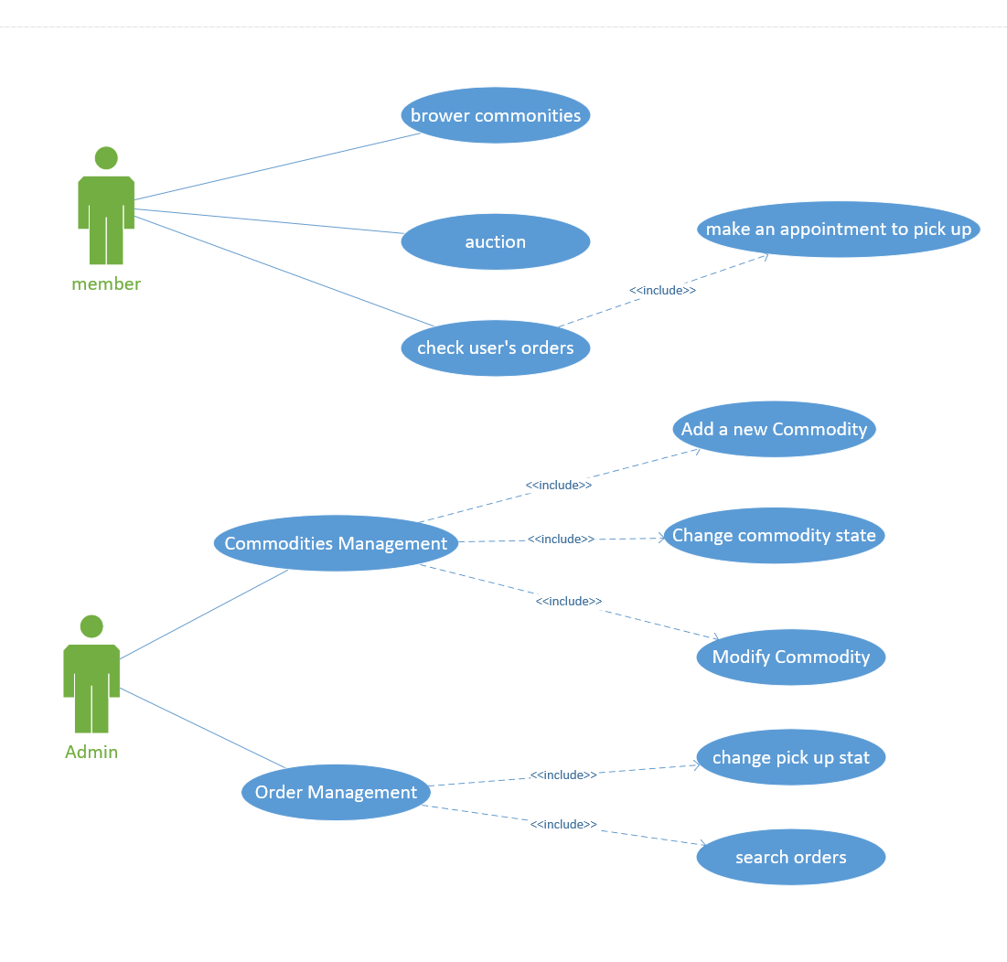

### User management.

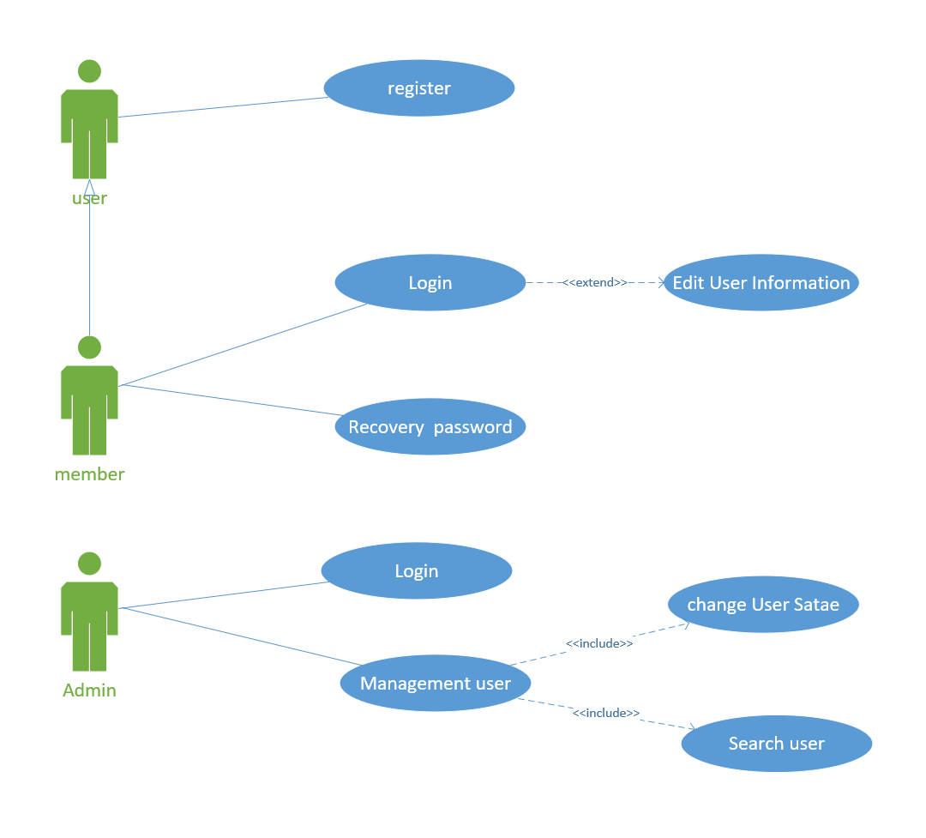

# Prototype

## Main Page

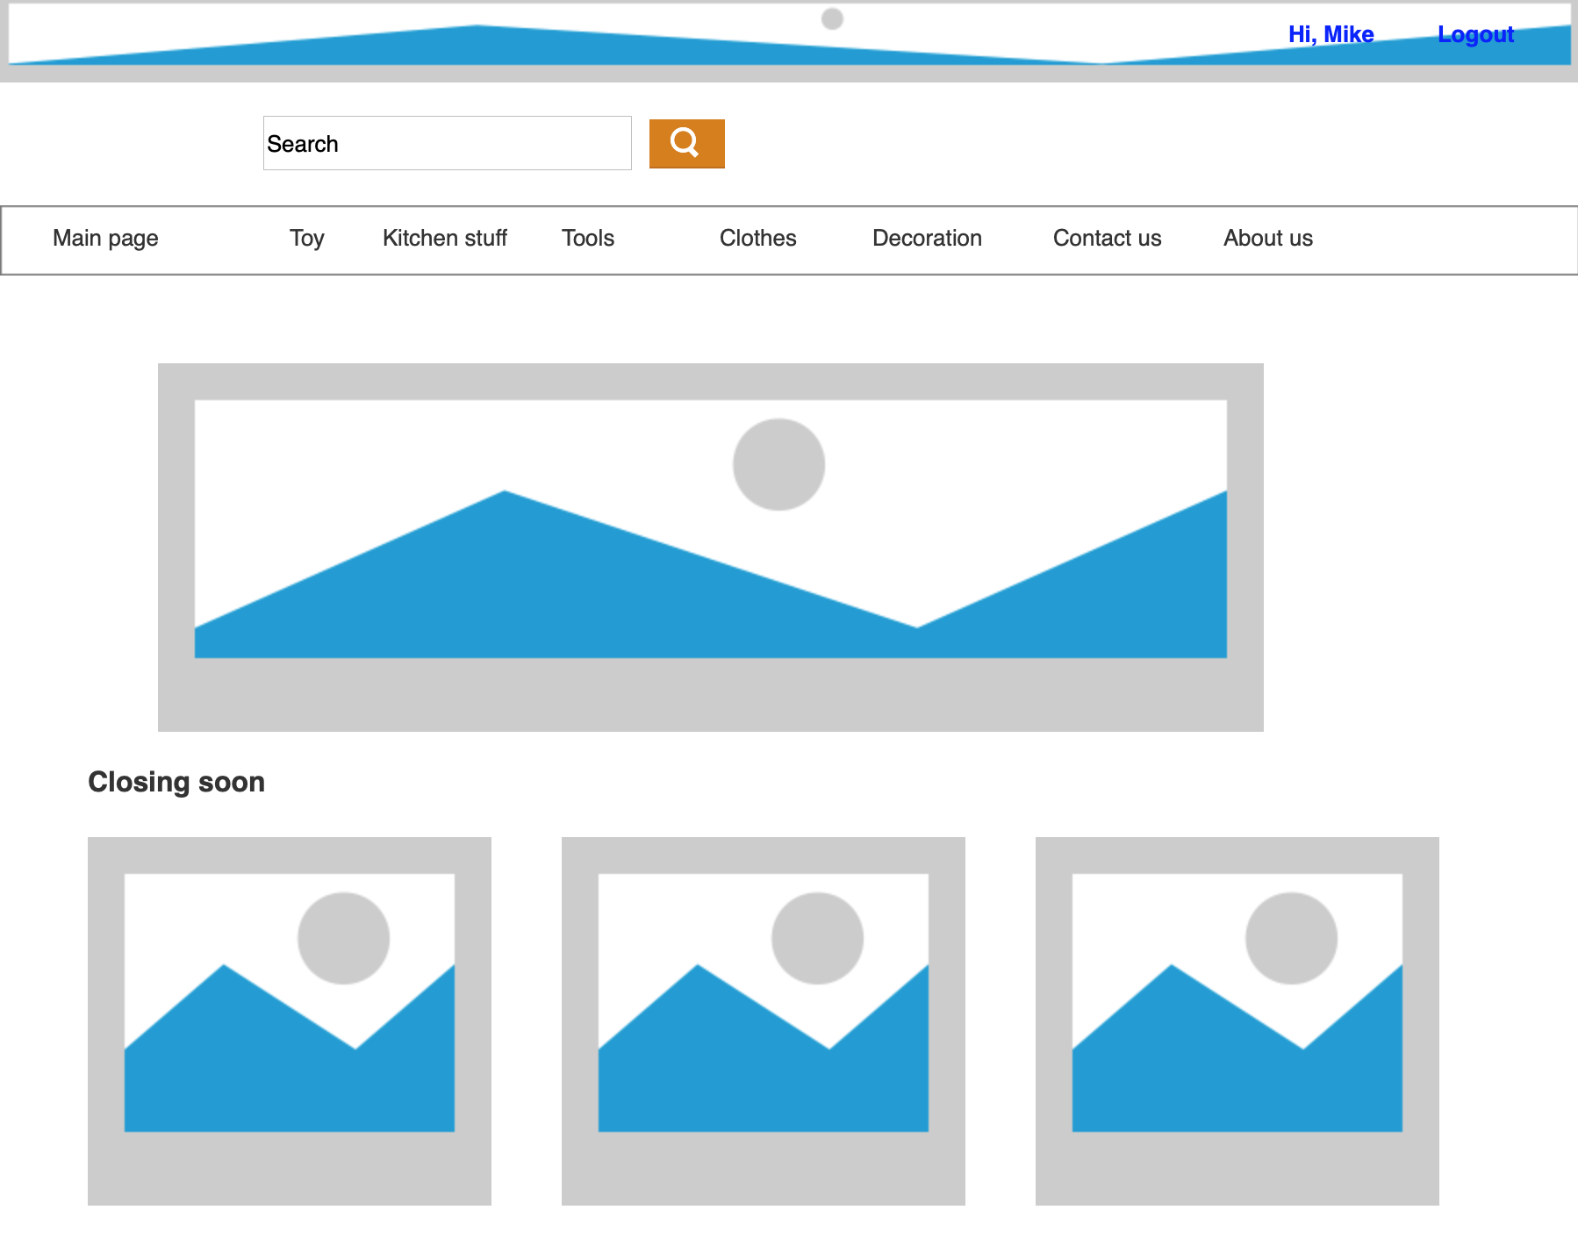

## Contact Us



## About Us



## Registration

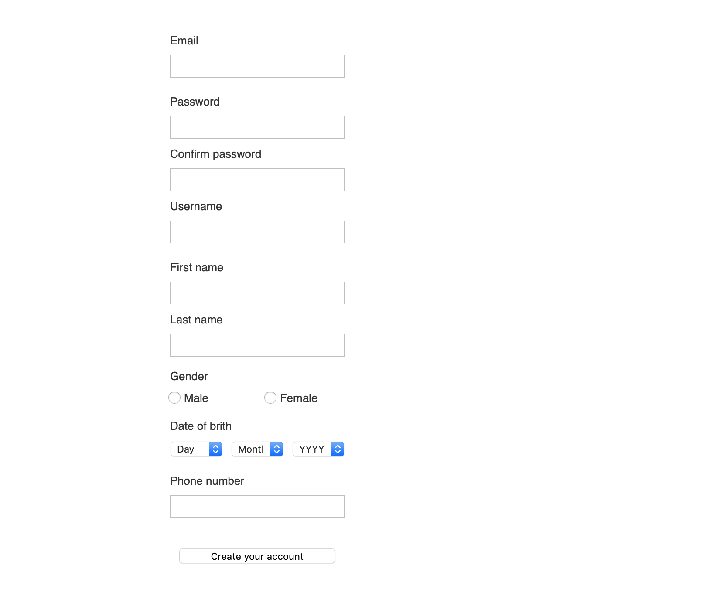

## Login

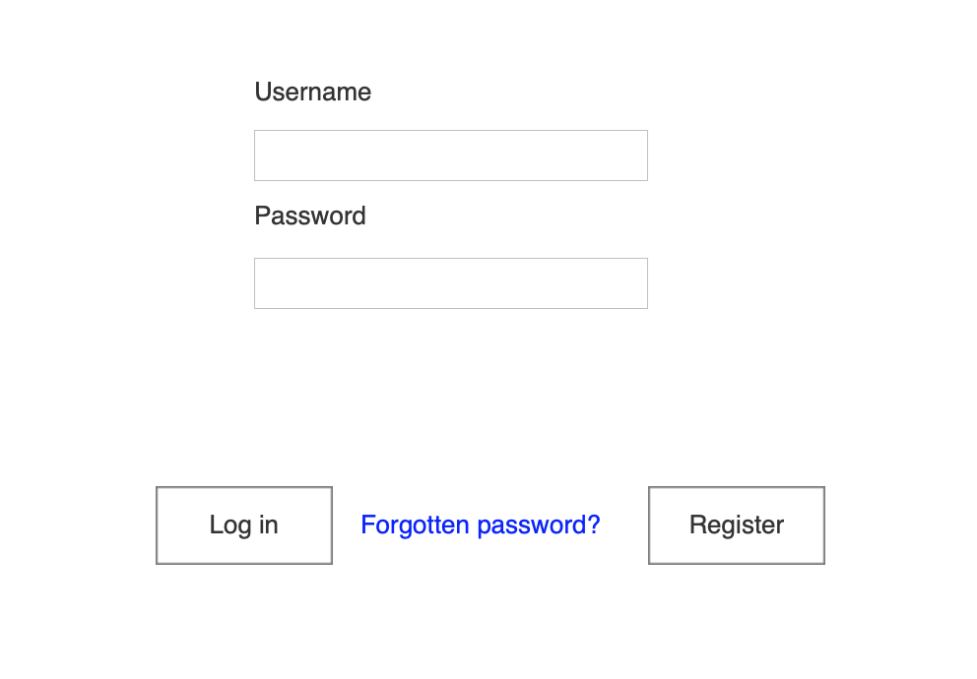

## Logout



## Password Recover

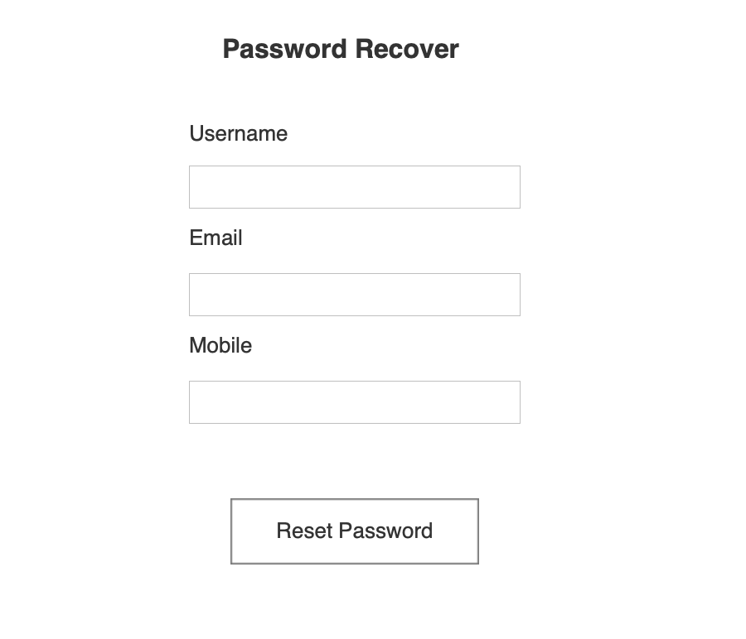

## Personal Information

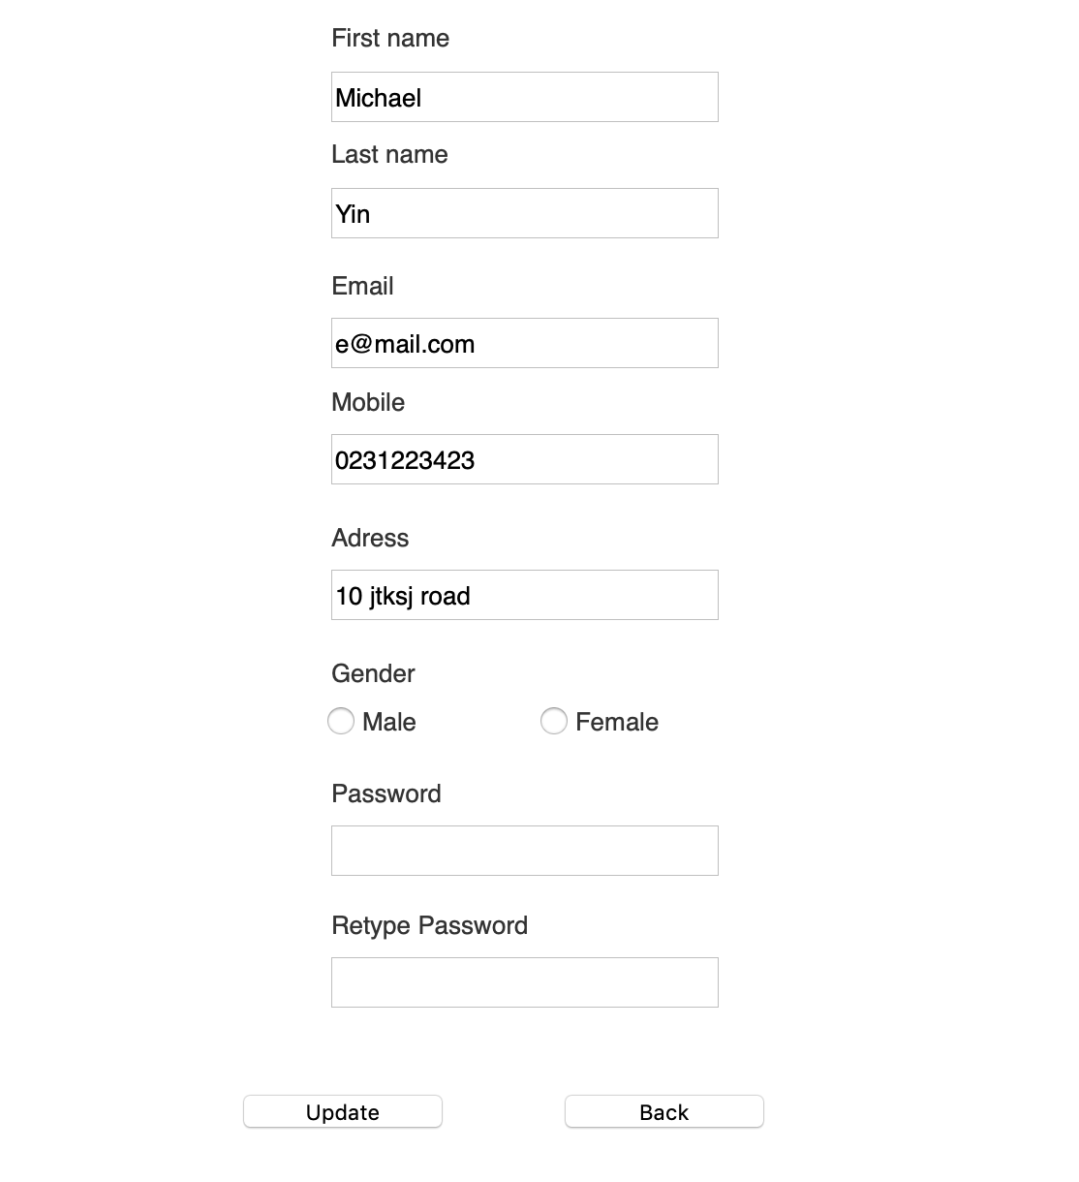

## Auction

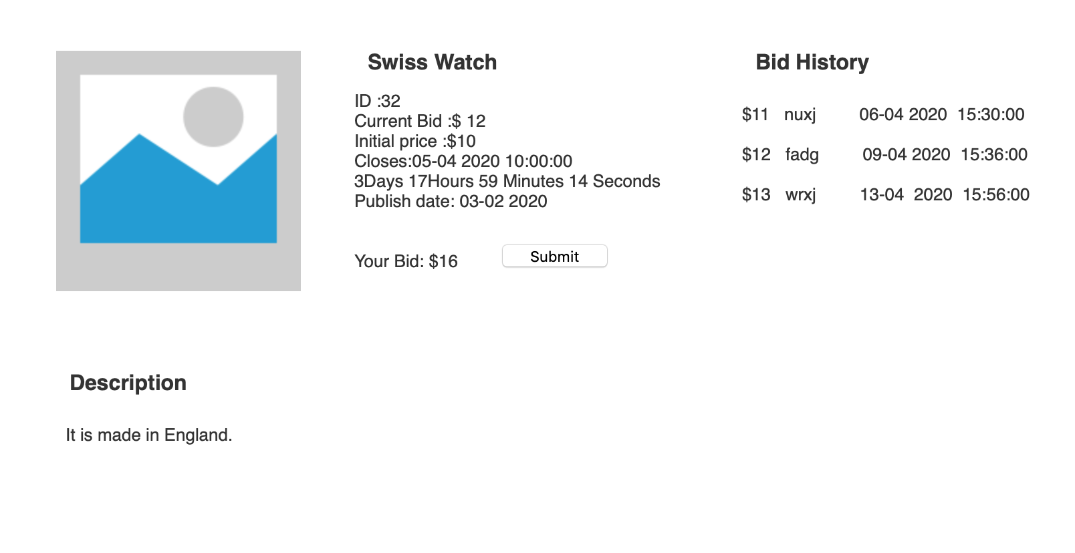

## Make Appointments

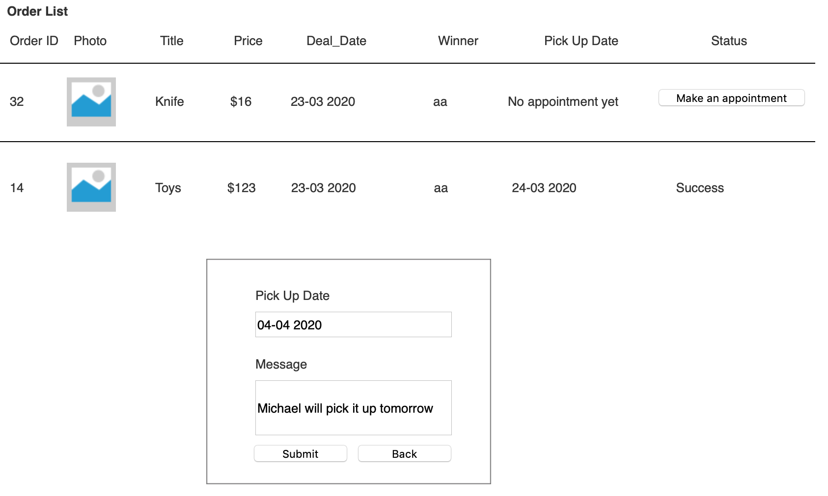

## Goods Management

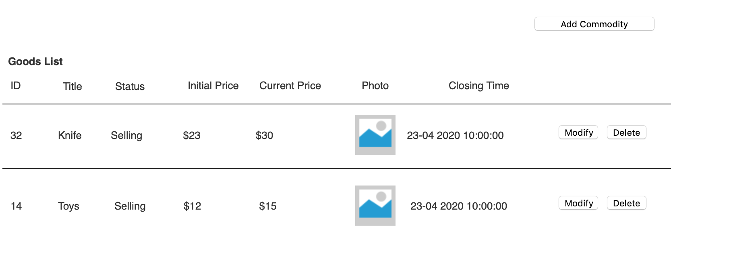

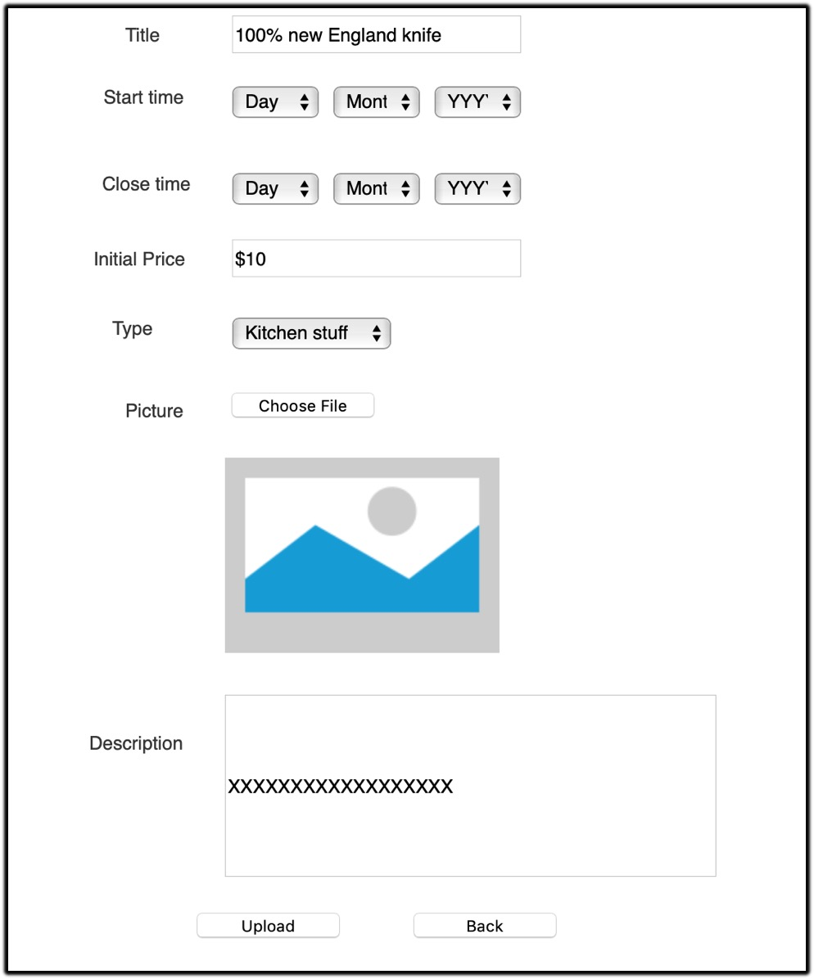

## Shopping Cart

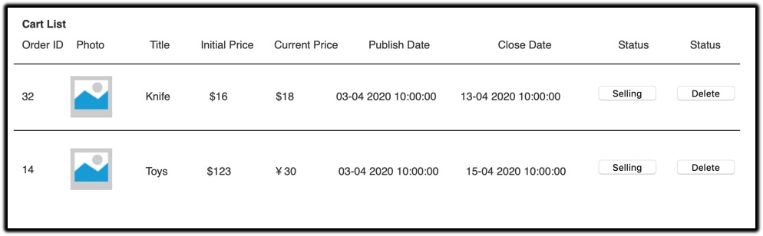

## User Management

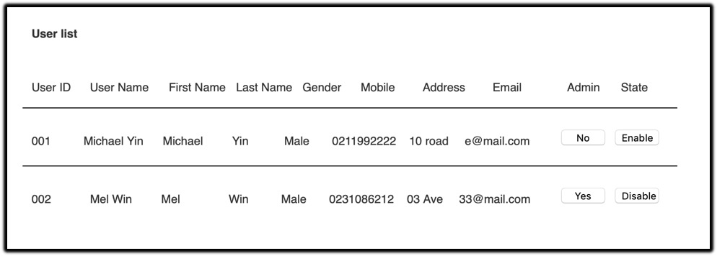

## Order Management

